

Practices for Secure Software Report

Table of Contents
Document Revision History 3
Client 3
Instructions 3
Developer 4
1. Algorithm Cipher 4
2. Certificate Generation 5
3. Deploy Cipher 6
4. Secure Communications 6
5. Secondary Testing 7
6. Functional Testing 8
7. Summary 9
8. Industry Standard Best Practices 9

Document Revision History

Version | Date | Author | Comments
1.0 | June 21, 2026 | Rebecca Scranton | Initial submission of Practices for Secure Software Report

Client



Instructions

Submit this completed practices for secure software report. Replace the bracketed text with the relevant information. You must document your process for writing secure communications and refactoring code that complies with software security testing protocols.

- Respond to the steps outlined below and include your findings.
- Respond using your own words. You may also choose to include images or supporting materials. If you include them, make certain to insert them in all the relevant locations in the document.
- Refer to the Project Two Guidelines and Rubric for more detailed instructions about each section of the template.

Developer
Rebecca Scranton

Algorithm Cipher

The history of modern encryption is defined by a continuous race to outpace growing computing power. In the late 1990s, the Data Encryption Standard (DES) became obsolete when its 56-bit key size proved vulnerable to being easily cracked by brute-force attacks. In response, the National Institute of Standards and Technology (NIST) adopted the Advanced Encryption Standard (AES) in 2001 to secure sensitive government data. A similar evolution occurred in data integrity; older hashing algorithms like MD5 and SHA-1 were eventually deprecated due to collision vulnerabilities, which occur when two distinct files generate the identical hash string. Today, AES-256 and the SHA-2 family represent the industry gold standards, remaining highly resilient against modern cryptographic attacks.
To modernize operations and establish secure communications for Artemis Financial, deploying a combination of these current standards is highly recommended. The web application should utilize the Advanced Encryption Standard with a 256-bit key length (AES-256) to secure sensitive client data both at rest and during transmission. To fulfill the client's specific requirement for a data verification step, the Secure Hash Algorithm 256-bit (SHA-256) should be implemented. Together, these tools ensure that client financial plans, investments, and insurance data remain entirely confidential and untampered with.
These two cryptographic tools operate differently to protect the application. SHA-256 is a cryptographic hash function that processes input data of any size and converts it into a fixed-length, 256-bit checksum string. Because it is a one-way, deterministic function, any modification to a file will result in a completely different hash output, immediately alerting the system to data tampering. On the encryption side, AES-256 utilizes a symmetric-key structure, meaning the exact same secret key is used to encrypt and decrypt the information. Symmetric encryption provides the rapid processing speeds necessary for handling high volumes of financial data, making it far more efficient than resource-heavy asymmetric alternatives.
To maintain strict security boundaries, symmetric encryption relies heavily on random number generation. AES-256 uses cryptographically secure random numbers to generate Initialization Vectors (IVs). An Initialization Vector is a unique, random block of data combined with the plaintext before the encryption process begins. This ensures that even if two identical financial files are encrypted by the system, they will yield entirely unique ciphertexts. Utilizing unique initialization vectors prevents malicious actors from detecting data patterns or performing replay attacks against Artemis Financial’s web interface.

Certificate Generation
Insert a screenshot below of the CER file.
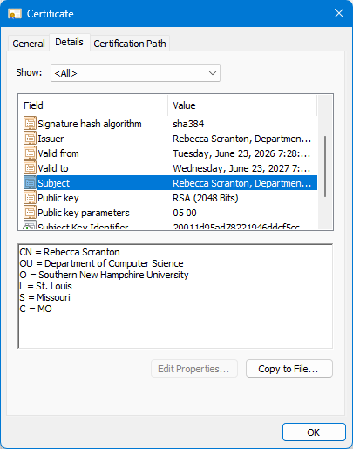
Figure 1: Details of the self-signed certificate (artemis.cer) generated via Java Keytool, showing RSA 2048-bit encryption.

Deploy Cipher
Insert a screenshot below of the checksum verification.

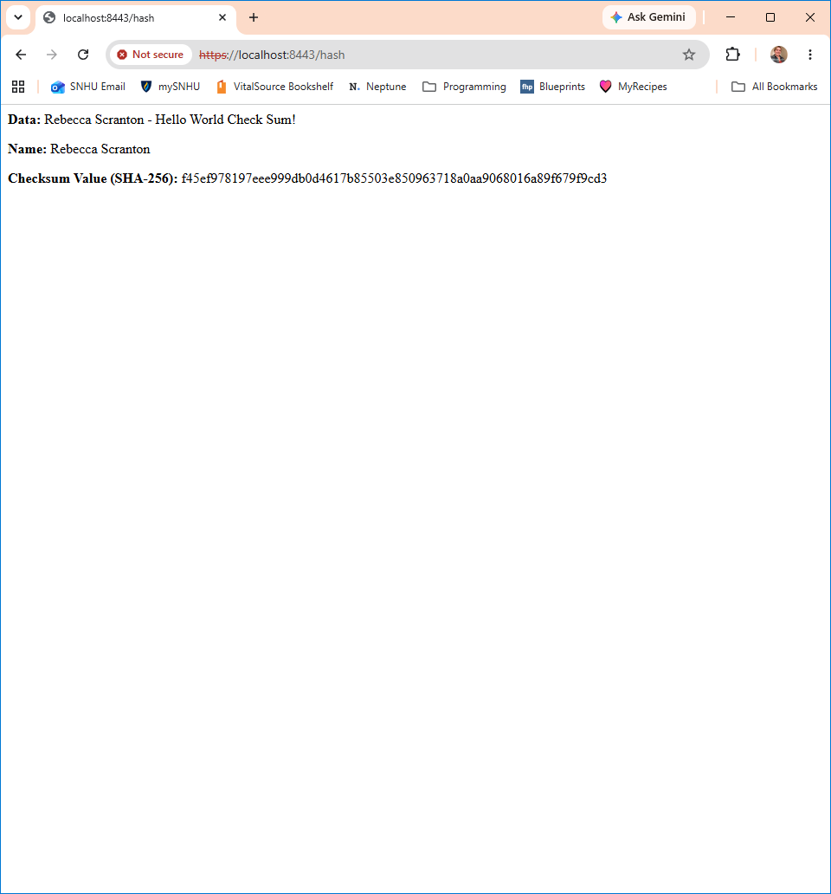
Figure 2: Successful SHA-256 checksum verification displaying the unique data string and calculated hash output.

Secure Communications
Insert a screenshot below of the web browser that shows a secure webpage.



Figure 3: Browser demonstration of the application running via the HTTPS protocol on port 8443. The application was successfully refactored to use HTTPS on port 8443. As expected in a local development environment, the browser displays a trust warning because the certificate is self-signed rather than issued by a recognized Certificate Authority (CA). However, the communication channel itself is securely encrypted.

Secondary Testing
Insert screenshots below of the refactored code executed without errors and the dependency-check report.
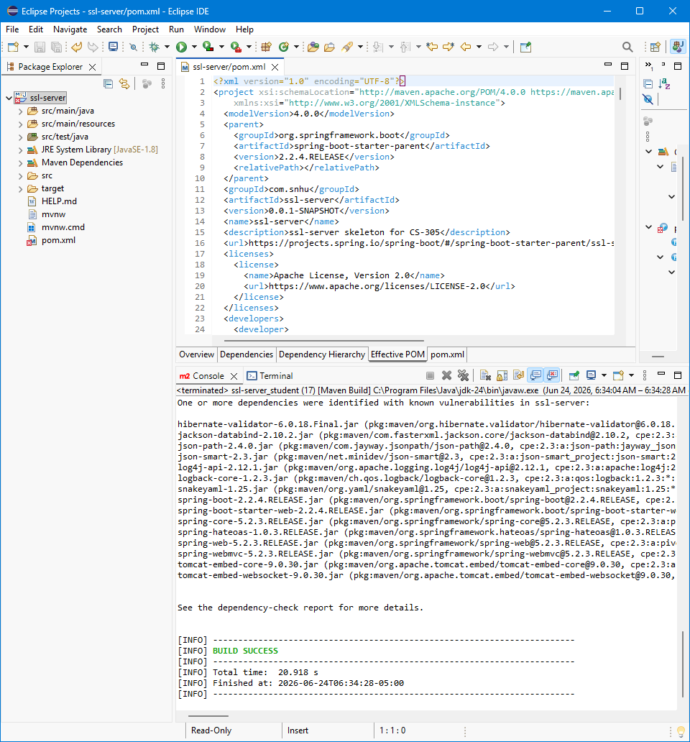
Figure 4: Eclipse console output demonstrating a successful Maven build and execution without fatal errors.

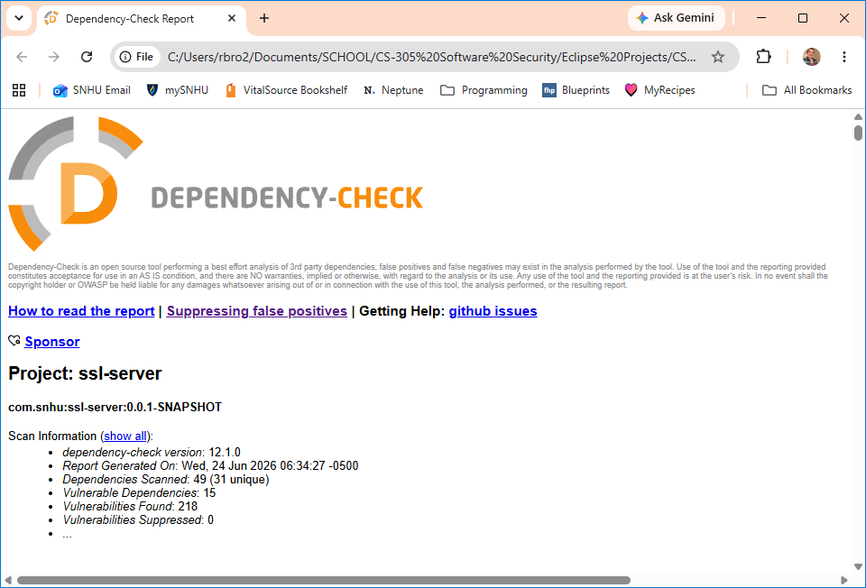
Figure 5: Summary overview from the OWASP Dependency-Check report detailing the vulnerability analysis.

Functional Testing
Insert a screenshot below of the refactored code executed without errors.
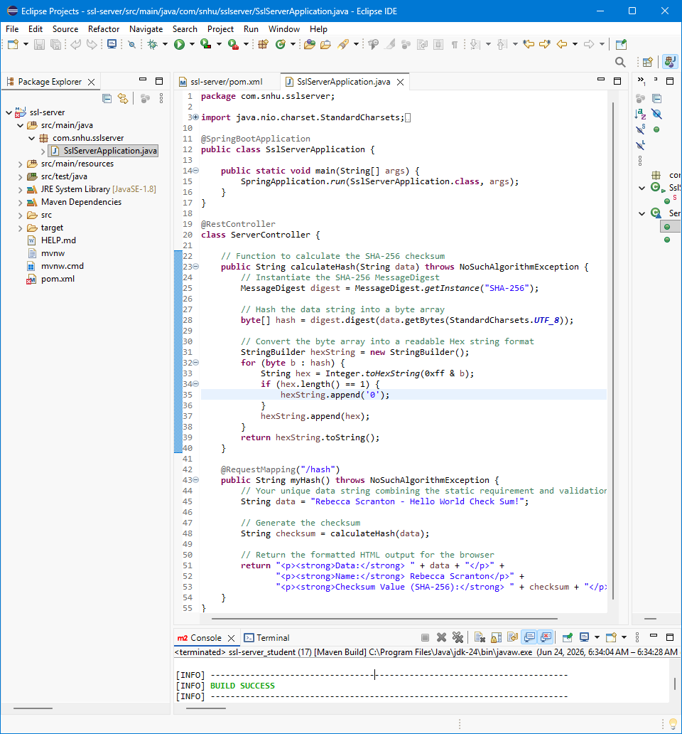

Figure 6: Manual code review of the refactored SslServerApplication.java. The console output at the bottom confirms the application was compiled and executed without errors (BUILD SUCCESS).

Summary

The vulnerability assessment process for this project followed the structured methodology outlined in the vulnerability assessment process flow. This process began with an architectural review to identify security domains requiring remediation, specifically targeting Cryptography and Client/Server interaction. To ensure our refactoring complied with established security testing protocols, the application was subjected to static analysis via the OWASP Dependency-Check tool. This testing verified that the security enhancements—specifically the integration of cryptographic hashing and secure transport protocols—were implemented without introducing new vulnerabilities, thereby complying with the "Secure Coding Practices" and "Secure Data Structures" domains identified in the assessment flow.
The refactoring process implemented a defense-in-depth strategy, adding multiple layers of security to the software application. First, to address data integrity, the application logic was refactored to incorporate a SHA-256 cryptographic hash function, ensuring that transmitted data could be verified for tampering. Second, to address transit security, the application was refactored to convert the communication protocol from insecure HTTP to encrypted HTTPS, utilizing a secure PKCS12 keystore. By systematically addressing these specific architectural domains—namely Cryptography and Client/Server composition—these modifications successfully hardened the application against common attack vectors.

Industry Standard Best Practices

To maintain the software application’s existing security posture, industry standard best practices were prioritized throughout the refactoring phase, specifically adhering to the "Secure Coding Practices/Patterns" domain identified in the vulnerability assessment process flow. Instead of utilizing custom or proprietary security mechanisms, the refactoring leveraged established, peer-reviewed standards. This included performing static security testing using the OWASP Dependency-Check tool to ensure that new code additions did not introduce insecure dependencies or regressions, thereby supporting the "Code Quality" and "Secure Data Structures" objectives. Furthermore, the implementation of SHA-256 for integrity and TLS/HTTPS for transport followed standard cryptographic protocols, ensuring interoperability and resilience. By applying these multiple, non-dependent security layers—a strategy known as defense-in-depth—the refactoring ensured that the system remained robust and that a failure in one area would not render the entire application insecure.
Applying these industry standard best practices for secure coding is essential to the overall well-being of the organization for several critical reasons. For a financial application, trust is the primary asset; therefore, adhering to these standards ensures that client data remains confidential and protected, preventing the potential loss of customer confidence that often follows security breaches. Additionally, standardized security protocols provide a demonstrable "due diligence" trail, which is vital for meeting financial industry regulations, reducing legal liability, and avoiding the significant costs associated with data breaches. Finally, by integrating security best practices during the development lifecycle rather than as a reactive measure, the company significantly reduces the long-term cost of technical debt, as it is far more cost-effective to build security into the application architecture than to perform emergency remediation after a vulnerability is exploited.

